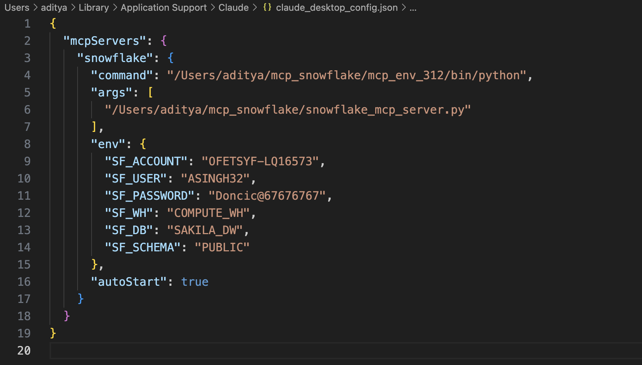
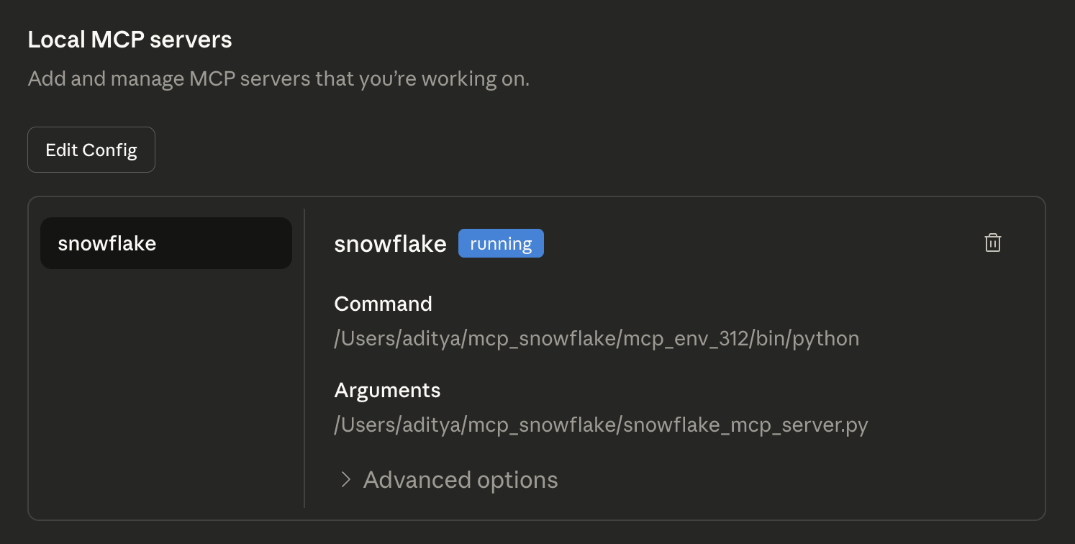
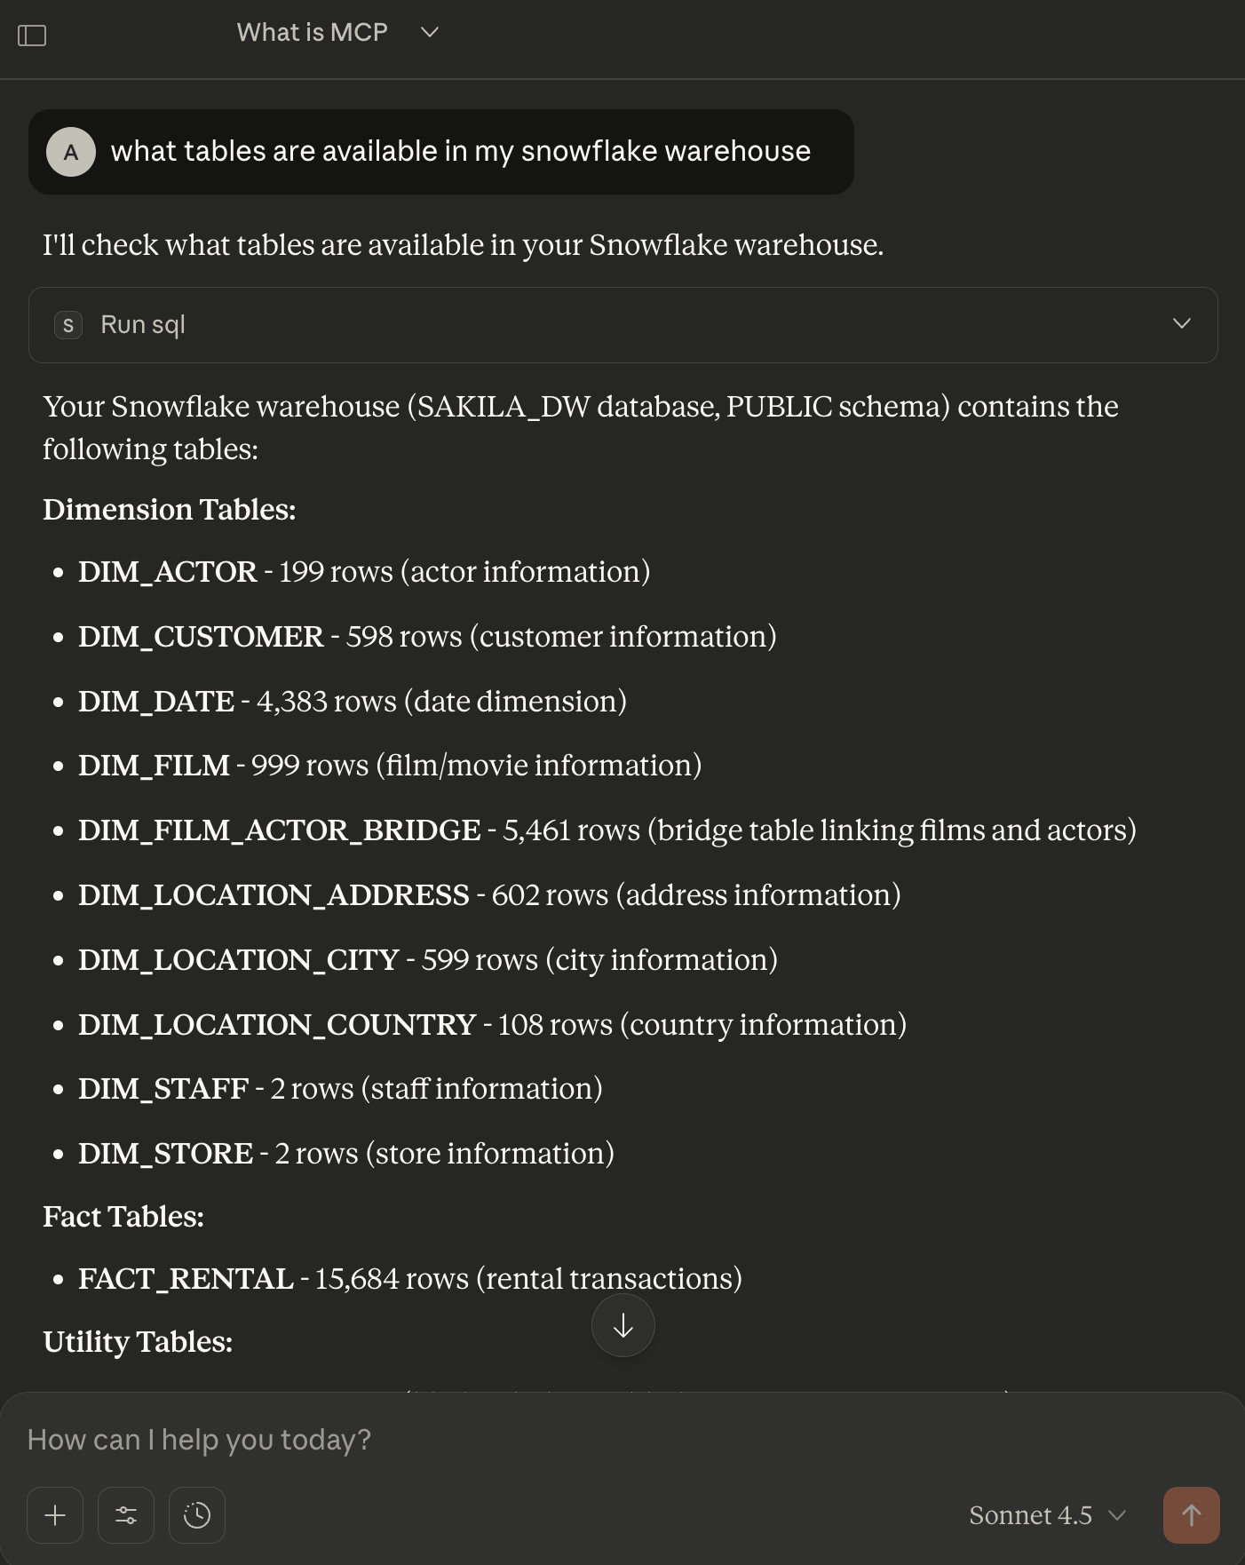


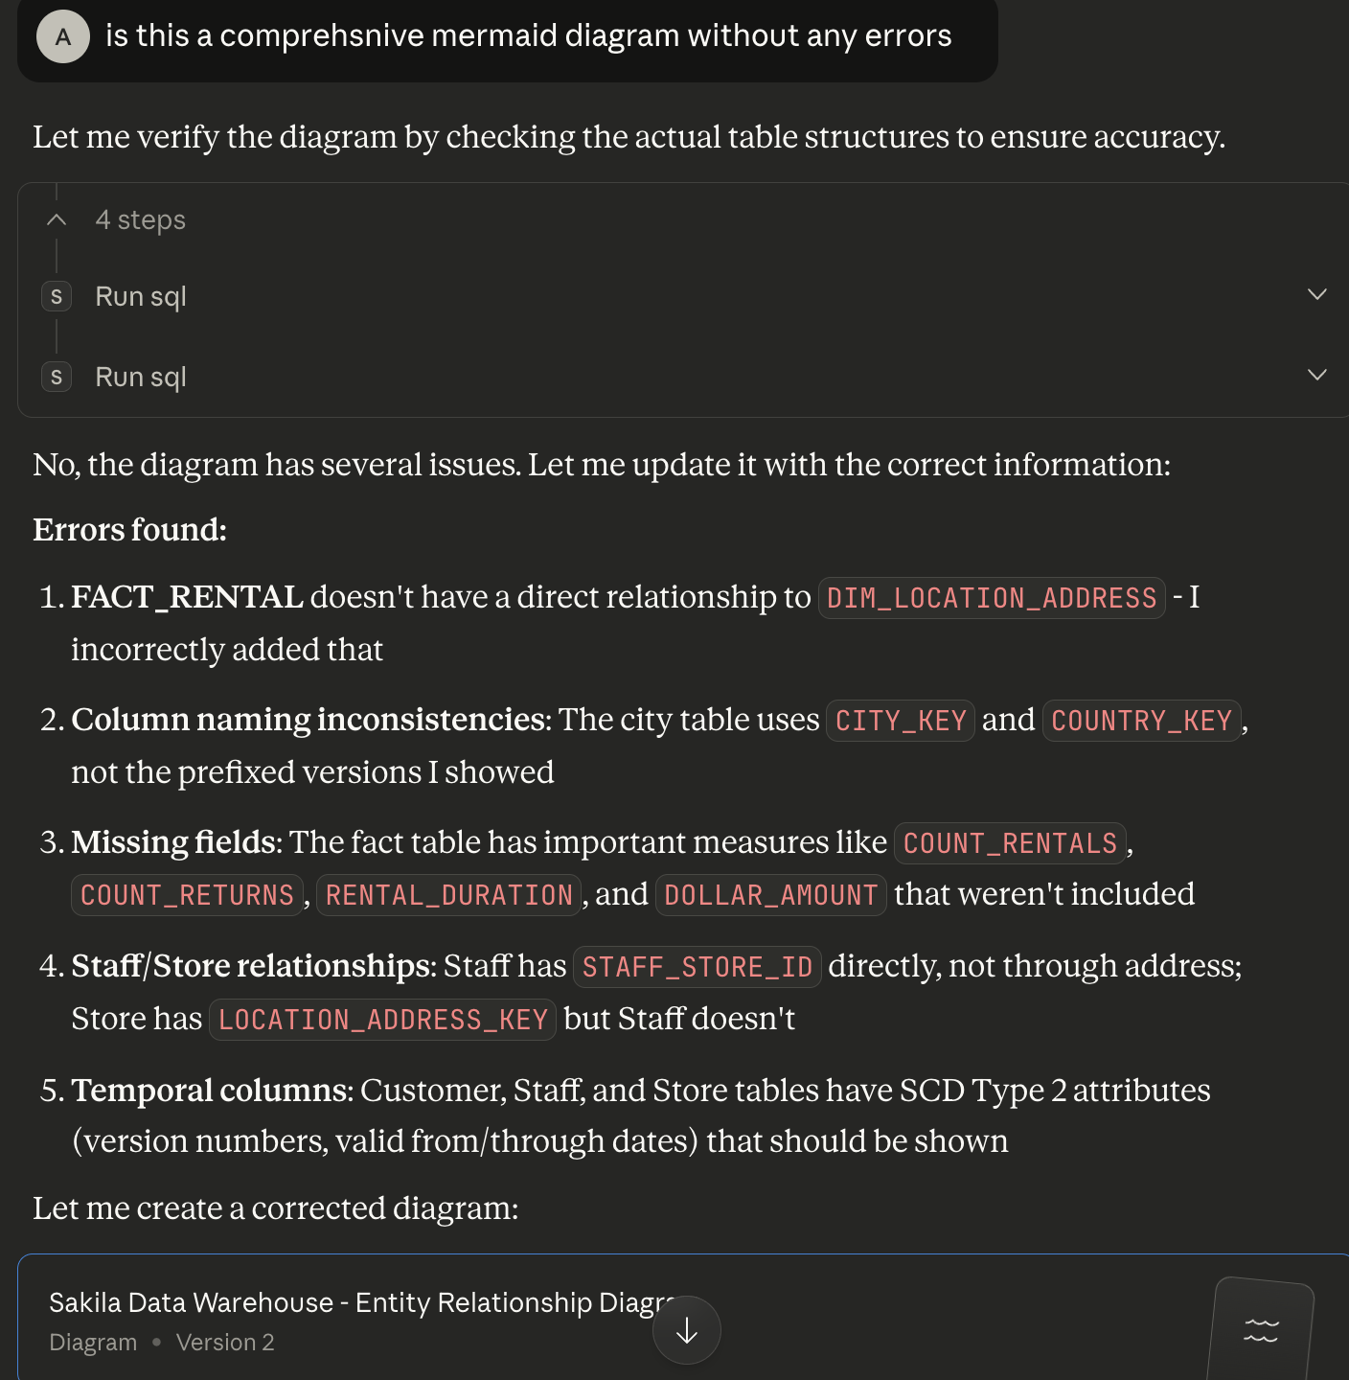

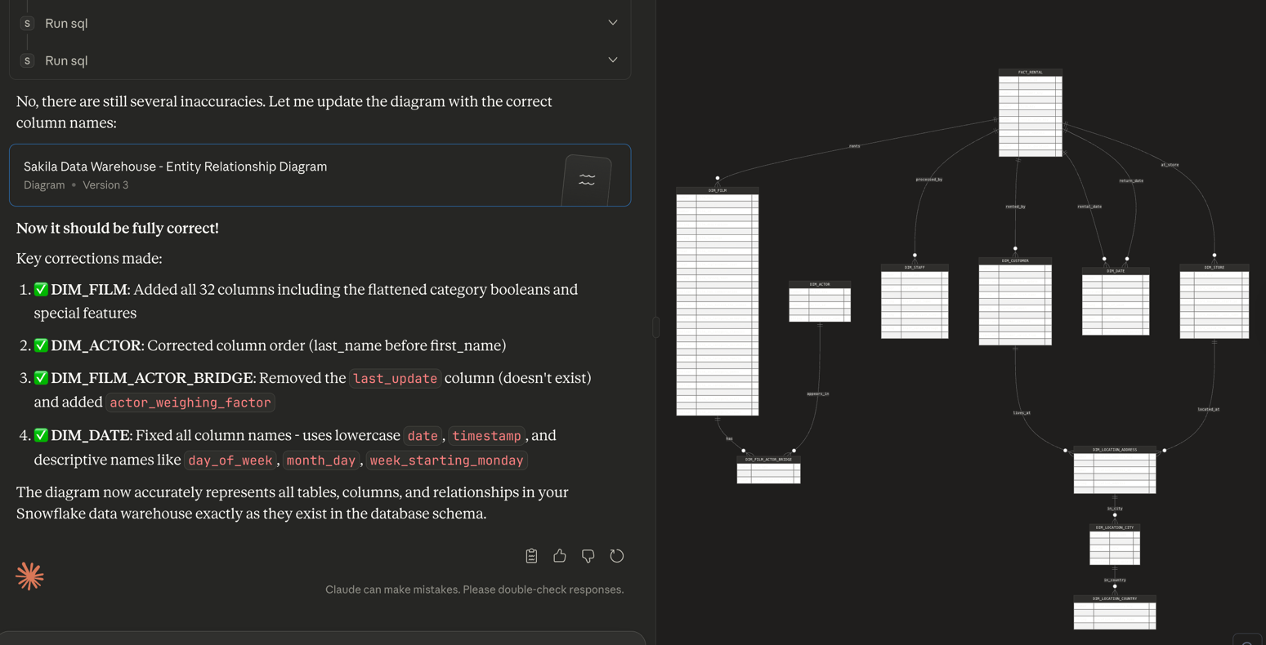
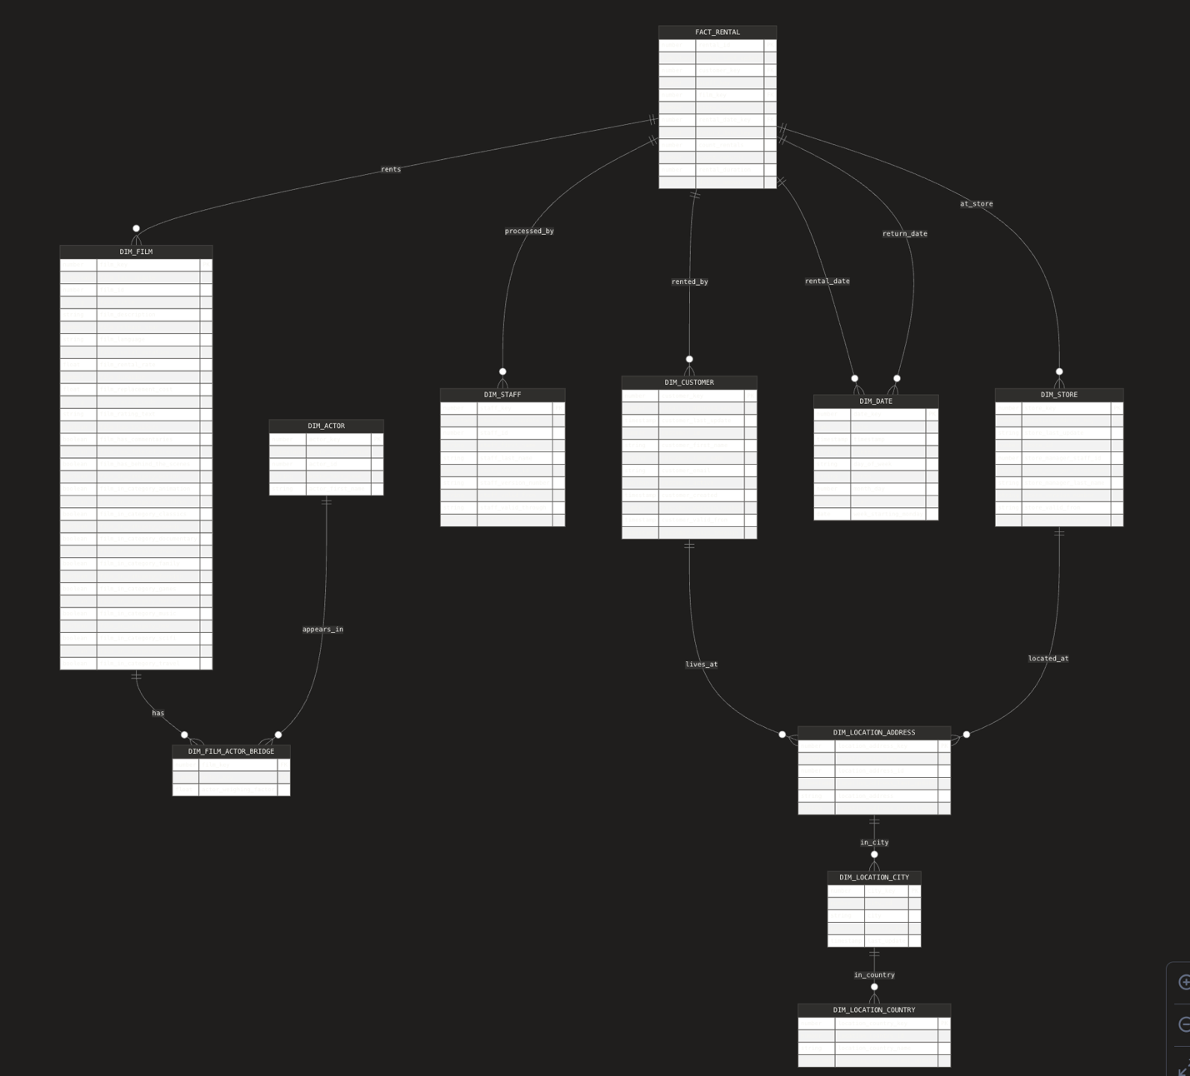
Summary of Issues Encountered During the Snowflake MCP Server Setup
Throughout the process of setting up the Snowflake MCP server for Claude Desktop, several categories of issues repeatedly appeared: environment conflicts, outdated MCP examples, invalid paths, runtime errors, and toolchain incompatibilities. Below is a combined summary of what went wrong, why it happened, and how the problems were ultimately resolved.
1. Python Version and PATH Conflicts
The system had multiple Python installations simultaneously active (macOS system Python 3.9, Homebrew Python 3.12, Conda Python 3.13, and Anaconda 3.13). Claude kept launching the MCP server using the Anaconda Python interpreter, which was incompatible with the FastMCP server. This caused missing attributes, module import failures, and silent hangs. The fix involved cleaning .zshrc and .zprofile, disabling Conda auto-activation, ensuring Homebrew Python 3.12 was the default interpreter, and building a clean virtual environment under Python 3.12.
2. Outdated MCP SDK Examples
Many initial errors (missing capabilities, missing run_stdio, incorrect call_tool usage, missing tool_handlers, etc.) resulted from following examples written for older versions of the MCP SDK. The newer SDK relies on FastMCP and decorator-based tools. The solution was to rewrite the server using the modern FastMCP API, which resolved these structural errors.
3. Incorrect Paths in Claude’s Configuration
Claude repeatedly failed to attach to the MCP server because of incorrect file paths. The original directory contained a space (mcp snowflake), which caused Claude to silently reset configuration files and ignore the server entry. Moving the project to a directory without spaces (mcp_snowflake) and updating the MCP server JSON configuration fixed these issues.
4. Event Loop and Runtime Errors
Errors such as RuntimeError: Already running asyncio in this thread occurred when attempting to wrap FastMCP’s internal event loop with anyio.run. This caused the server to crash immediately. This was resolved by simplifying the startup code to call mcp.run() directly.
5. Cache and Config Reset Issues
Claude Desktop repeatedly reverted the configuration because cached files under
~/Library/Application Support/Claude/config-cache* were overriding changes. Deleting these stale caches ensured Claude loaded the new server settings correctly.
6. NPX and CLI Failures
Attempts to use npx @modelcontextprotocol/cli consistently failed.
Final Outcome
After correcting the environment, rewriting the server using FastMCP, updating the directory structure, resetting Claude caches, and cleaning the PATH, the Snowflake MCP server finally initialized correctly. Claude Desktop successfully connected, recognized the run_sql tool, and completed the full MCP server connection.

